Nova: “The Last Extinction” Name:
Work alone!
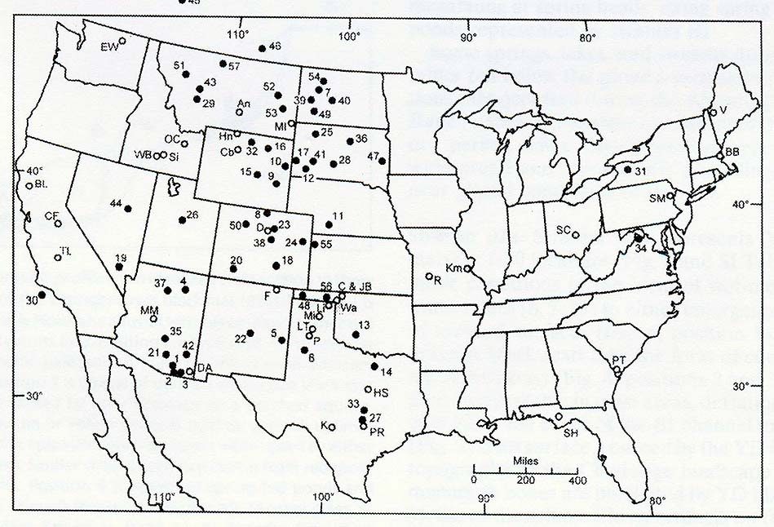

1. How many years ago did this “last extinction” happen?

2. What element, common in meteorites and asteroids,
can be found in elevated levels below the “black mat”?
(The map shows locations where the mat has been found.)

3. Explain why ice formed from snow that fell during an
ice age tends to contain so much dust.

4. What do we call spear tips made by the first people to inhabit North America?

5. What specifically (besides “how they lived and died”) can be learned from sloth dung?

6. Besides the comet impact theory, what is one of the other theories about the cause of the last extinction? (Briefly explain.)

7. According to ice cores drilled in the 1990’s, how did the climate change at the time the great land mammals went extinct?

8. Dirt from the time of the last extinction contains carbon spherules. What was found inside these spherules?

9. Describe one of the two scenarios that would explain the lack of a crater?

10. Besides containing an “iridium spike”, how did ice samples taken from Greenland support the idea that a comet killed off the mammoths, giant sloths, sabre-tooth cats, etc.?

